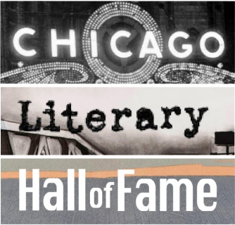

NEWS RELEASE

For release: Immediately

Chicago Literary Hall of Fame wins

Chicago Community Trust Acting Up Award

Chicago, June 20, 2018 – The Chicago Literary Hall of Fame (CLHOF) has been awarded a Chicago Community Trust (CCT) Acting Up grant to help fund its proposed “From the Porch of Gwendolyn Brooks” program. Based in Brooks Park at 46th and Greenwood in Chicago’s Kenwood community, “From the Porch” is inspired by the sculptural tribute to Ms. Brooks by sculptor Margot McMahon, commissioned by the CLHOF, and unveiled in the park in June 2018. The installation includes a statue of Ms. Brooks and a replica of the porch where she wrote poetry as a child.

“This will help us to develop meaningful programming on and around the Gwendolyn Brooks statue,” said Donald G. Evans, Founding Executive Director of the CLHOF, “and will go a long way in ensuring that its dedication was just the beginning of a long and worthwhile presence in the park.”

The Hall of Fame will tap its network of local writers and educators to help mentor neighborhood children, encouraging them to explore their own lives through a greater understanding of the life and work of Gwendolyn Brooks. The children will celebrate their accomplishments by reading their creative work on the Brooks porch at community events this summer and fall. The CLHOF will then print a publication featuring the work of the children. The journal could be used as a fund-raising tool for the park or schools, or distributed at no charge.

Launched in 2016, the CCT Acting Up awards provide recipients monetary prizes to help them implement their ideas, work together and take action for the public good. The award process began with the CCT On the Table program where applicants met with community leaders and representatives of the CCT to exchange and develop ideas. The applicants then submitted a grant proposal in the form of a short video.

“What an honor,” said Jean Westrick, Director of Civic Engagement and Partnerships, CCT, in an email, “to be working alongside individuals, like yourselves, who are motivated and driven to make a difference in the city we all call home.”

The award was presented to the CLHOF Friday, June 20, 2018.

